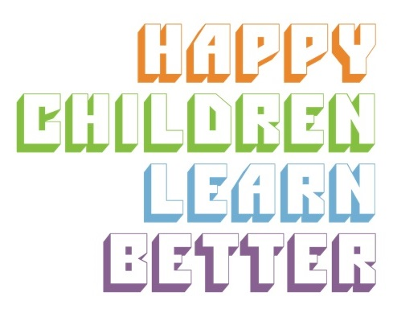

INTRODUCTORY SET - LOOK INSIDE COMMUNICATION BITE
We recommend that after each assembly you send out the corresponding communication bite for parents/carers.
You can cut and paste the text into your own school newsletter to introduce the INSIDE OUT charity and the 5 Keys to Happiness.
5 KEYS TO HAPPINESS

This year we are working with an education charity called INSIDE OUT whose mission is to improve the wellbeing of primary school children.
There is a strong public health message on 5 fruits and vegetables a day but what are the 5 things you can do every day to feel happier and look after your mental health?
This is where INSIDE OUT helps.
The charity has taken the ‘5 Ways to Wellbeing’, an evidence-based approach to improving wellbeing recommended by the UK government, and created a child-friendly version called the ‘5 Keys to Happiness’.
Through the 5 Keys, children gain a ‘toolkit’ of fun and practical life skills that they can use in their daily lives to help them reduce stress, increase confidence and build resilience. INSIDE OUT’s motto is: happy children learn better!
We understand that you want to help your children to be happy and healthy both inside and out. So over the next term, we will be introducing the 5 Keys in our newsletters and sharing fun and simple activities you can try at home with your children to support our work in school.
This week’s Key is LOOK INSIDE which inspires self reflection, focusing, being quiet and self-calming.
The LOOK INSIDE Key helps children develop:
- A common language to discuss emotions
- An awareness that there is a range of emotions and it’s ok to feel them
- A variety of strategies to help focus the mind, regulate emotions and reduce anxiety
Sometimes it can be hard for children to describe their feelings so INSIDE OUT uses the language of weather to help describe them. For example: sad = rainy; happy = sunny. It is important for children to realise that all weather is welcome, just as plants need all types of weather to grow, we need all feelings to be healthy.

This week at school we had a go at an FBW which stands for Feet, Breathe, Weather. The FBW is a simple breathing technique to help children calm their mind and body and improve their weather inside. It can be used ANYWHERE and ANYTIME.

If you want to have a go at an FBW at home, please follow these simple steps:

F … Feel your Feet on the floor.

B … Feel your Breathing - place one hand on your belly and one hand on your chest. Close your eyes. Take a few deep breaths. It’s a bit like your belly is a balloon getting bigger and then getting smaller.
- Breathe in and feel your belly rise and breathe out and feel your belly fall.
- Breathe in 1...2...3… and breathe out 1...2...3...
- Breathe in and feel your belly rise and breathe out and feel your belly fall.
- Breathe in 1...2...3… and breathe out 1...2...3...

W … Feel your Weather inside - you and your child could each share what your weather inside is now. Hopefully, it is calm and the weather inside is sunnier. Remember to emphasise that all weather is welcome.

If you are concerned that your child is feeling stormy or unsettled a lot of the time, please come and talk to your child’s class teacher.

